Implementation Scenario

One in four American adults (93 million) are now family caregivers. Traditional nursing homes and assisted living facilities are not going to meet the demand of the Boomer generation. Many families find themselves unable to afford such facilities and most seniors prefer to stay in their homes and remain connected to their communities.

Consider the case of a widow in her late eighties who is becoming less able to live independently and take care of herself and manage the range of chronic conditions that need to be attended to. One of her daughters has had to assume the role of primary caregiver balancing caring for her mother with her other family and work obligations.

As families assume a greater role in the care of their frail older or ill relatives and find themselves overwhelmed as they try to coordinate the range of caregiving tasks and responsibilities (see Figure 1).

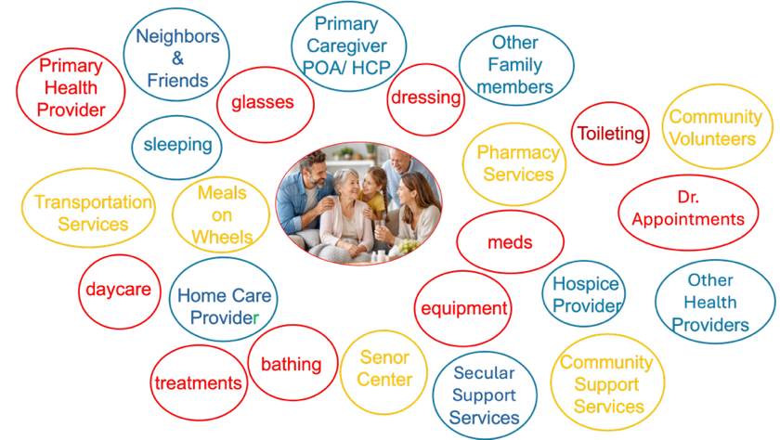

Figure 1. Chaos of Caregiving
They can’t do it alone. Communities must help families address the needs of frail older and disabled individuals living in their community. With the dramatic weakening of facility-based long-term care options in the Unites States, the only solution lies in enabling families to manage, organize, and orchestrate care. Only communities can connect families to the necessary tools and to community programs and resources that will enable their frail older members to age safely in place, preventing unnecessary losses and costly hospitalizations.

The mission of the non-profit The National Association of Community Aging Circles, Inc. (NACAC) is to work with the leadership of community organizations, to enable their older members and others who need support to remain safely at home and connected in their communities. We work with community organizations to provide orientation, training, and support for communities and their families to identify, manage, and orchestrate all the resources needed to age in place.
NACAC’s objective is to help develop and support community leadership in transforming aging in the United States by providing communities and families with consulting, training, tools, technological solutions, and ongoing support to manage and coordinate the care needed to keep an individual at home and connected to the community. As individual communities adopt the NACAC model, NACAC will provide a platform to share best practices and demonstrate that community-based solutions better meets the needs of families and is cost-effective.
There is a foundational tool, the easy-to-use Jointly app developed by CarersUK (https://jointlyapp.com/jointly-at-glance) that helps caregivers develop a “circle of care” that organizes and coordinates all the information, tasks, resources, and individuals involved in a person’s care. The Jointly app has been used successfully for over a decade by over 30,000 carers in the UK.
CarersUK also provides a range of resources to carers in the UK through their website (https://www.carersuk.org/ ) and associated programs (https://www.carersuk.org/for-professionals/join-our-professionals-network/ ). These include instructions and tips on how to create ‘circles of care’ as well as opportunities to connect with other carers to share best practices.
Working with CarersUK, NACAC will provide US families with a seamless connection of the Jointly app. Using the CarersUK model, NACAC is creating a website (www.nacac.org) that will provide a range of resources for caregivers in the US. It will include instructions on how to use the CarersUK Jointly app to create ‘circles of care’ for frail older and ill individuals in the US.
2026 Initial Implementation Phase
NACAC is identifying community organizations that are committed to supporting families caring for older, ill and disabled relatives. NACAC will work with the leaders of those organizations to identify families who would be willing to participate in NACAC’s program. If a family is interested in participating, NACAC will provide the family with an access code so that they can use the Jointly app, at no cost, to create a ‘circle of care’ around their loved one. NACAC will work with these families and community leadership to help them organize and coordinate the caregiving and resources for their loved ones.
Each ‘circle of care’ will include all of the individuals and community services who are involved in caring for the family member (Figure 2). Everyone in the ‘circle of care’ will be able to communicate with the others in the ‘circle of care’ and be aware of the range of care activities/tasks being performed and who is responsible for each one.
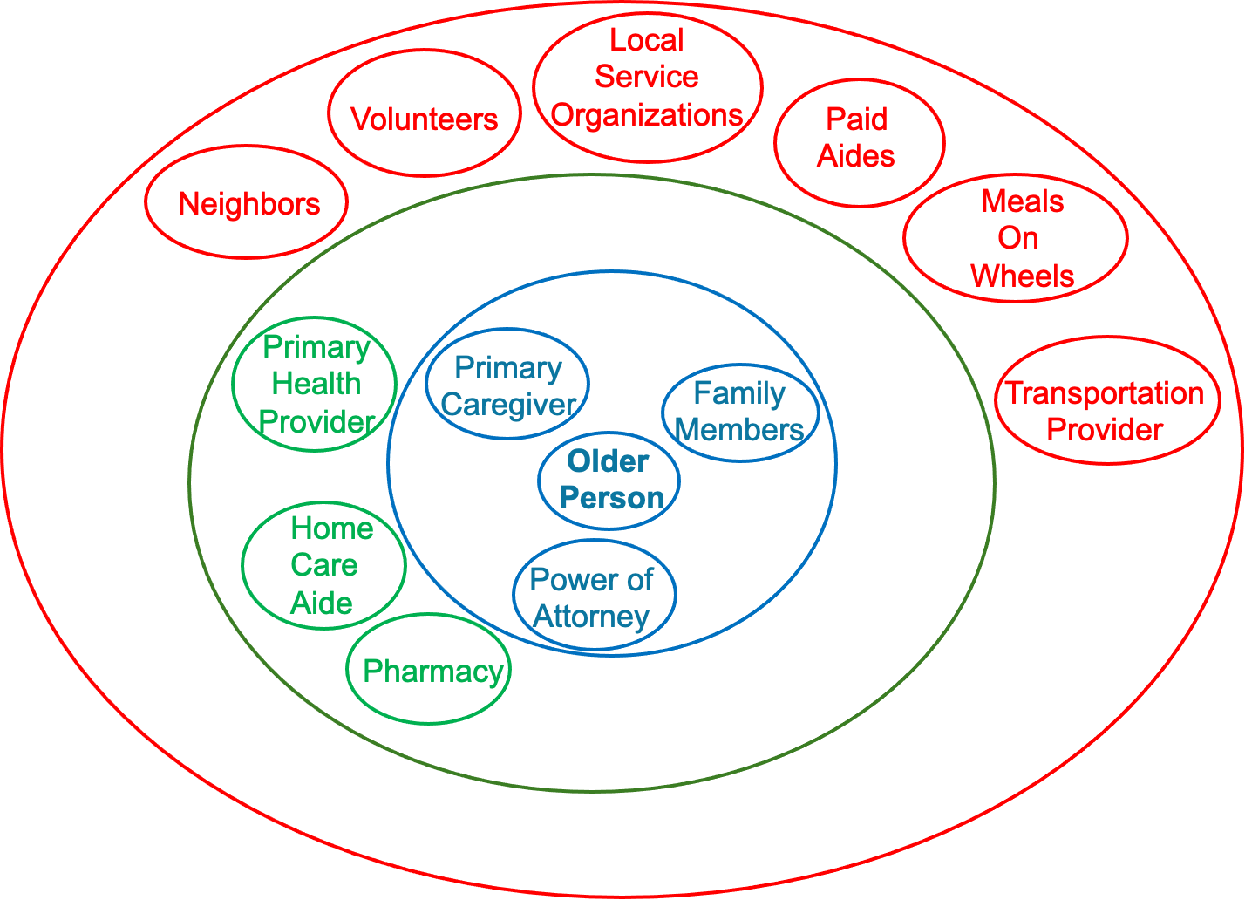
Figure 2. Circle of Care
NACAC will develop Jointly training materials (print and video demos) that will be made available on the NACAC website and be used with ‘circle of care’ members in one-on-one training sessions (live on site and/or via Zoom). The website may also sponsor live chat sessions for family members as well as other members of care circles. NACAC, using the CarersUK model, will post links to resources & services available in particular communities as well as links to other resources about caring in the home. NACAC will also provide these materials and links for community organizations to post on their own websites.

2027 Full Implementation Phase: NACAC continuing licensing agreement with CarersUK
The National Association of Community Aging Circles-USA (NACAC) will continue to provide support to community organizations that are members of the association by sharing best practices, helping member organizations develop resources, and foster growth of community organization-based systems that enable older and disabled community members to live fully and safely in their own homes. The NACAC will continue to license CarersUK’s Jointly app and make it available to families of participating community organizations in the U.S. The goal is to create community leadership around aging.(see Figure 3)

Figure 3 Full Implementation
While community organizations will continue to identify those in their community who could benefit from access to the Jointly app and the range of resources available in the community, it is important to note that community organizations will not be taking on the responsibility of providing care or services.

