FAQS

What is a circle of care?
A circle of care includes all the individuals who participate in the care of a frail or ill individual. The circle of care can include family members, friends, community volunteers as well as those who are paid to provide care or other services.
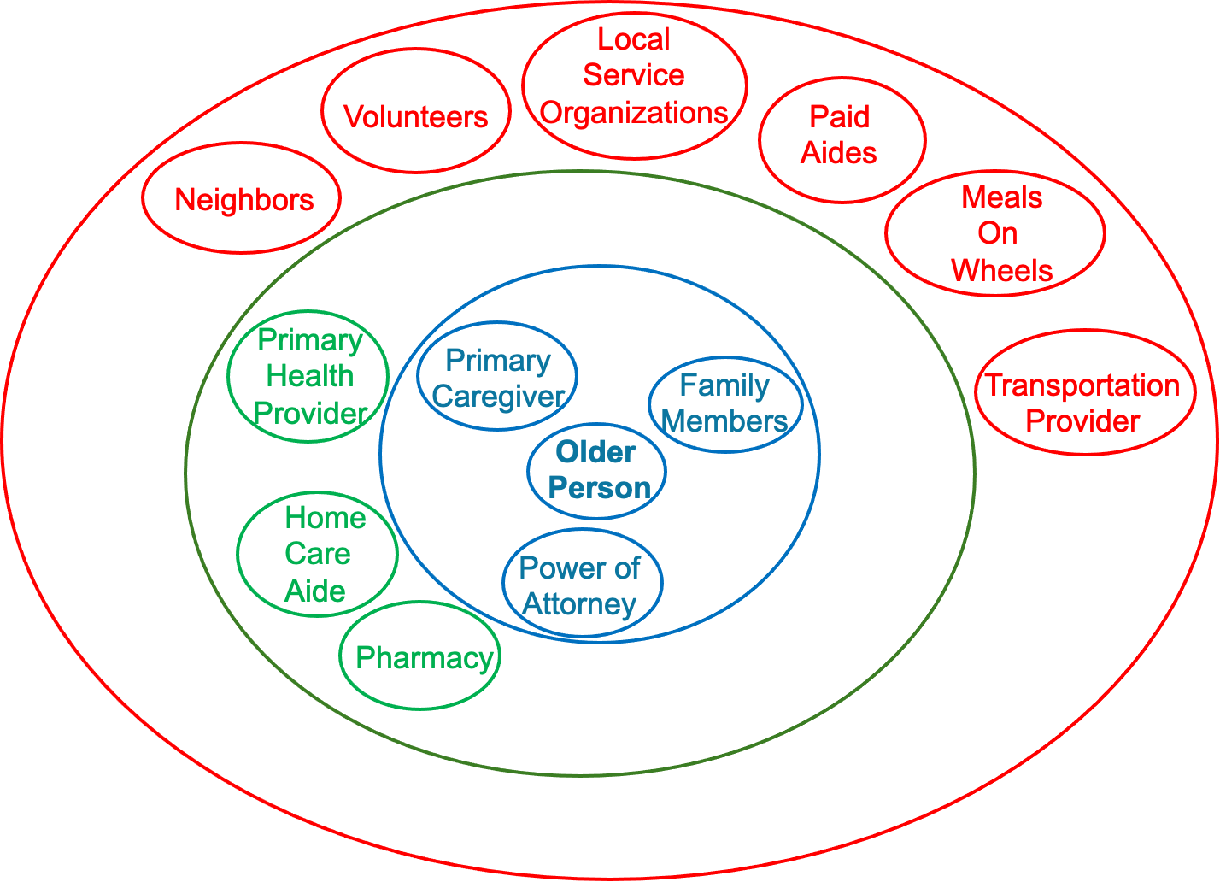
What is the National Association of Community Aging Circles?
NACAC’s objective is to engage and foster community leadership in transforming aging in the United States by providing communities and families with the framework, tools, and technology to manage and coordinate what is needed to keep older people at home and connected to the community.

How can my community join the National Association of Community Aging Circles?
First complete the NACAC community enrollment form at NACAC.ORG and then execute the NACAC membership agreement.
How can I get a family in my community access to the Jointly app?
Provide NACAC the name, email and preferred phone number of the individual who is responsible for the care of a frail or ill family member.
How can I get training on how to use the Jointly app?
The NACAC provides PowerPoint and video tutorials at the NACAC website NACAC.ORG and can upon request provide in person or online training.

What is Jointly?

Jointly is a mobile and online application created by carers for carers. It is designed to make caring a little easier, less stressful and a lot more organized. It combines group messaging with other useful features including to-do and medication lists, calendar and more! Use it with others or on your own.
How do I use Jointly?
Please see the Jointly user guide for more details on how to use Jointly, including how to sign up, invite other users in your circle and how to manage, edit and delete information.
Please note that all members of your circle can view the information shared on Jointly. Use your common sense about what information you can share with the members of your circle.
How does Jointly work?
With Jointly you can create a circle of care for the person you are looking after. Once you have set up your Jointly circle you can start using Jointly to organize care. You can use it on your own or you can invite other people to join you and share the care. Jointly works on iPhone, iPad, Android devices and on most modern web browsers (home computers, laptops, smartphones, tablets, etc.).
- Simple, intuitive group communication: Communicate with everyone in your Jointly circle at a touch of a button! Simply post a message or upload an image.

Notes: Keep all your notes together - and never lose them again! Create a health log or store bills using text or image entries.

Tasks/lists: Keep organized and on top of things by using tasks and task lists. Simply create a task and assign it to any member of your Jointly circle, including yourself, and monitor its status.

Calendar: Create date/time specific events and invite anyone in your circle. You can also use the field provided to invite people outside your Jointly circle.

Profile page: Store useful information about the person you are looking after and have it available to access any time at a click of a button!

Medications: Use Jointly's Medications feature to keep track of current and past medication of the person you are caring for. You can also upload an image to quickly recognize a medicine.

Contacts list: Jointly allows you to store more useful contacts so that you can access their details anytime, anywhere!

Where can we get the Jointly app?
Jointly is available to download as a mobile app from Apple and Google Play stores. Available online at www.jointlyapp.com

On which devices can I use Jointly?
You can access Jointly on the following devices:
- iPhone and iPad, iOS version 9.0 and above
- Android devices, version 5.0 and above.
- Most modern web browsers (home computers, laptops, smartphones, tablets, etc.) at jointlyapp.com
Once you create a Jointly account you can use it to log in to Jointly on any device you choose. Download the Jointly app on your iPhone, iPad, Android phone or tablet or visit jointlyapp.com from any other tablet, mobile phone, laptop or home computer.

I can’t download the app to my Android/iOS device

The Jointly mobile app requires Android version 5.0 or later or iOS version 9.0 or later. If you are running an older version and the app store doesn’t let you download the app then please either update your phone software or use the web version at jointlyapp.com.
The web version of Jointly has the same functionality as the app version.

Is Jointly free?
You can visit jointlyapp.com or download the app for free and access the Jointly video, Jointly user guide and Jointly FAQs in order to find out more about Jointly.
Any member of a local community caring for a frail or ill family member can get a free access code through the National Organization of Community Aging Circles.
How do families get a Jointly access code to set up a circle of care?
Any member of a local community caring for a frail or ill family member can get a free access code through the National Organization of Community Aging Circles. That access code will enable the family to create a Jointly account and build a circle of care for the person being cared for. Once a Jointly circle of care has been set up, the primary caregiver can invite as many people as they want to become part of the circle of care. There are no additional cost to add people to the circle of care.

If I have received a free access code for Jointly from the National Association of Community Aging Circles, do I still need to buy Jointly?
No, if you have received a code for Jointly that means the National Association of Community Aging Circles has purchased a Jointly circle for you. You can redeem the code at jointlyapp.com and start using Jointly online or on your mobile. An access code can only be redeemed once per Jointly account, if you are caring for more than one person and would like to create more than one Jointly circle you can ask the National Association of Aging Circles to allocate you with a new code

How can I redeem a Jointly access code for a new circle?

If you have received an Access Code the National Association of Community Aging Circles then this can be used to redeem a free Jointly circle.

If you don’t have an account with, Jointly use the sign-up form to create an account. If you already have a Jointly account, log in to your account.
You will be prompted to create a new circle when you first log in to Jointly. You can start creating your circle by filling in some helpful information about the person you are looking after. You can always edit this information later from the Profile.
When you create your circle, please use the 'Free Access Code' option and enter the code that your employer or service provider has given you.

I am looking after more than one person. Can I have two or more Jointly circles of care?

Yes, you can create two or more circles of care. You will need to get an additional access code to create that circle.

I have invited someone to join my circle but they haven’t received the invitation email.
Make sure you have entered the correct information in the invitation form. You can see this in your Pending invitations and you can also resend invitations from here. Please ask them to check that your invitation email hasn't been incorrectly blocked as spam.
If the person registers a new account at jointlyapp.com or the mobile app using the email address you sent the invitation to then they will be able to accept the invitation when they first log in.
If you have any further problems, please contactjointlyappsupport@carersuk.org.

I forgot my username or password. What do I do?

If you forgot your password visit jointlyapp.com or open the Jointly app on your iPhone, iPad, Android phone or tablet. On the Log in screen click Forgot your password? In the screen that follows enter your email address. We will send you an email; follow the link provided in the email to reset your password. Now you can use your new password to log in.
If you forgot your username: Your username is your email address. If you recently amended your account settings including changing your email address you will need to use the new email address to log in.
If you have troubles logging in contact: jointlyappsupport@carersuk.org

Does Jointly work offline?
You can open the Jointly app and view its content when you are offline but you will not be able to make changes (add, edit or delete content) while you are offline.
Offline data may not be available if you have been offline for a while or if your device has cleared Jointly's temporary storage. Messages are not available offline. Please note that the data on Jointly may be out of date if your device hasn’t synced with the server recently.

How does Jointly manage data protection/storage?
All your data is transmitted via an encrypted connection to a secure server. Should the service cease, your data will be made available for download in CVS format.

I am experiencing a technical problem. Who can I contact?

If you are experiencing a technical problem, please contact jointlyappsupport@carersuk.org.

How do I delete my Jointly circle and account?
Please see the user guide sections ‘Circle settings and deleting your circle’ and ‘Edit/delete Account’. Please note that you must delete/leave any circles before you can delete your Jointly user account.

I have suggestions/feedback about the Jointly app. Who can I contact?
If you would like to make a suggestion or send feedback, please contact jointlyapp@carersuk.org.

